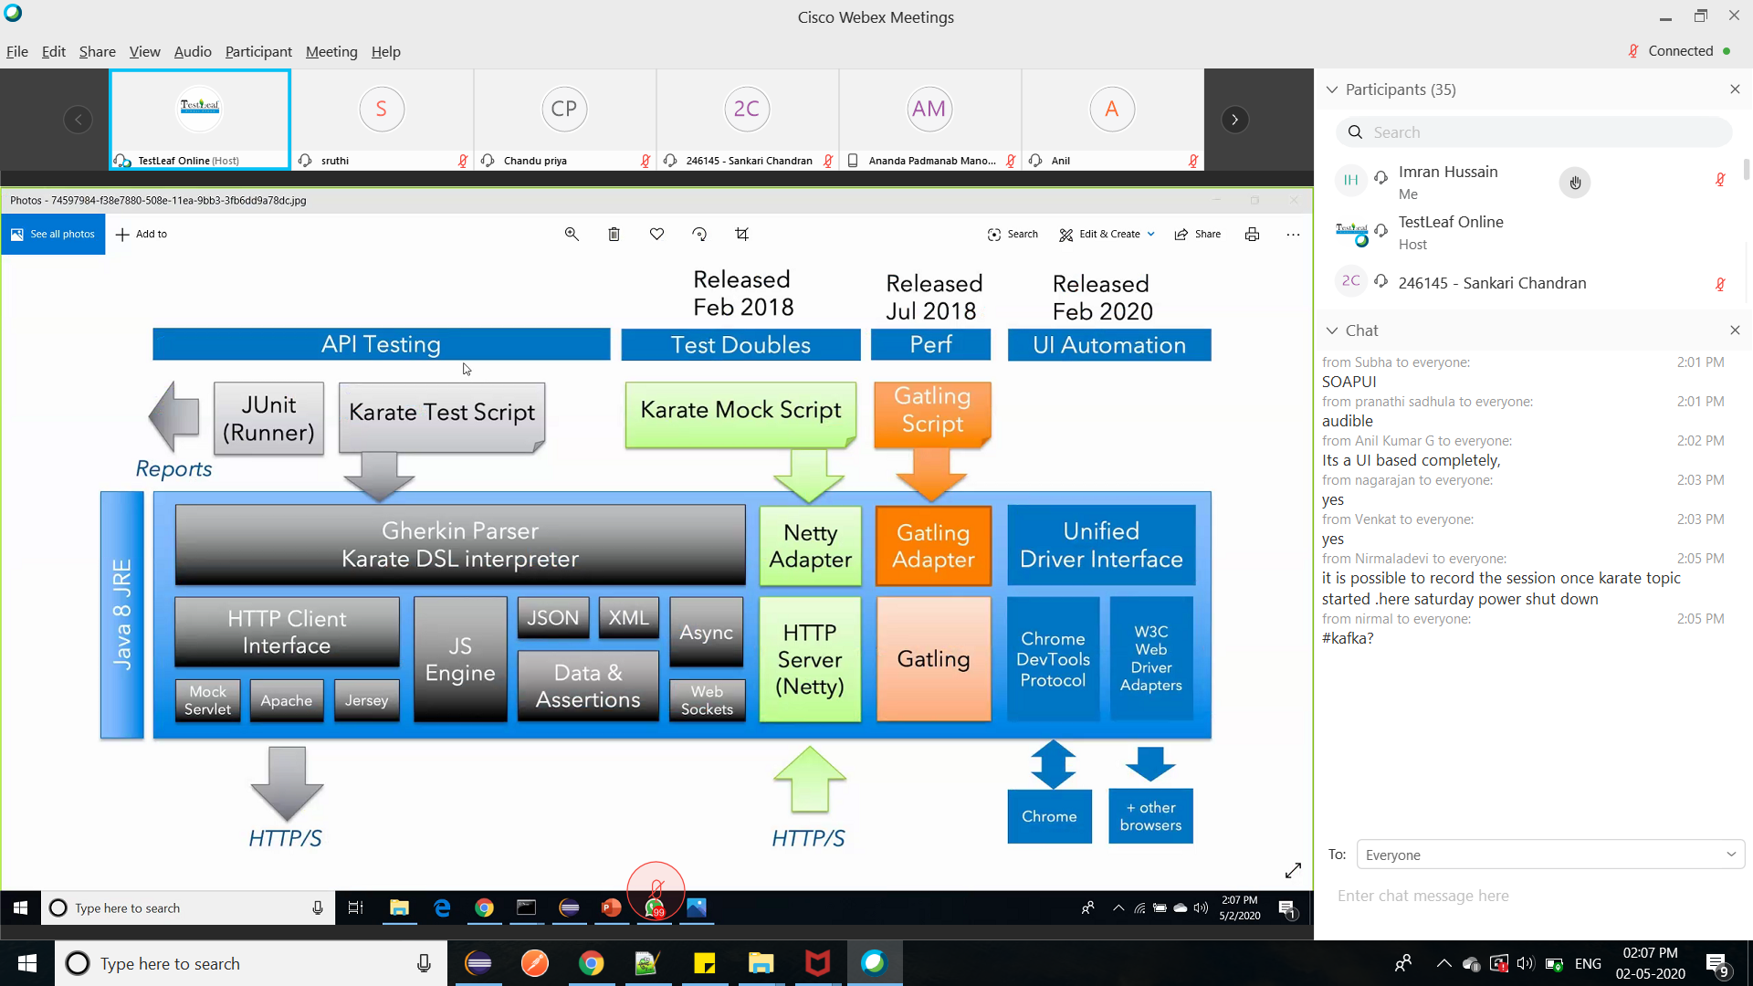

<https://twchennai.github.io/VODQA-Chennai/>

mvn dependency:tree -Dverbose

<http://frameworks.testleaf.com/>

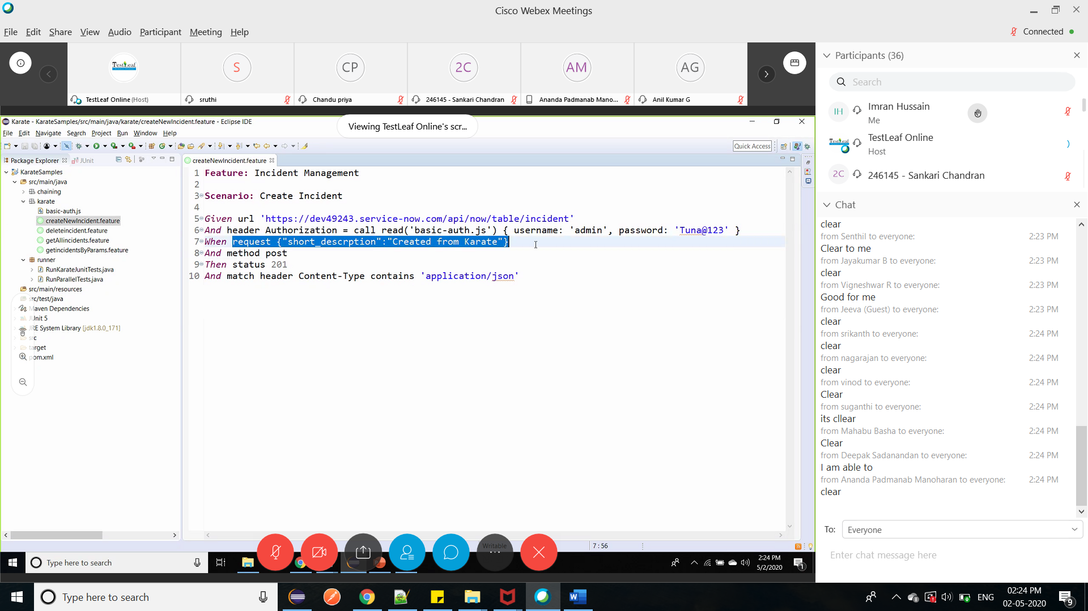

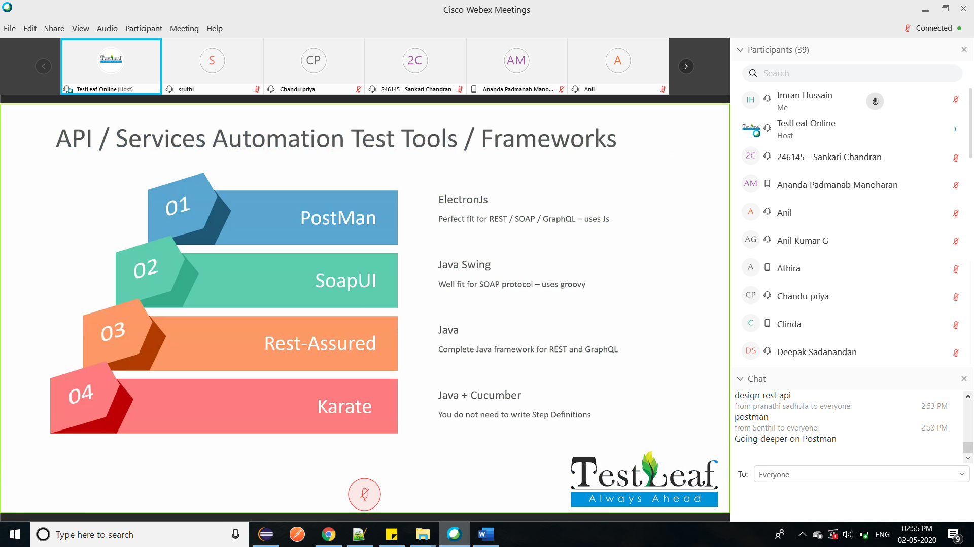

1. Design – how api works

2. Get deeper into Postman

3. Learn something more

